**Online Job Portal**

Rachna Jain

**Summary:**

This is an online job portal website implemented using Spring MVC and hibernate to allow users to post jobs as well apply for the posted jobs. The users can view all jobs posted on the website but you cannot apply to a job unless you are logged in. New users can register themselves to apply for the job. There is an option for registration on the log in screen for new users to create an account. Mail api is implemented which gives notification to the user when he applies for a new job. An employer can also post job on the website but he too needs to register himself to be able to post. An employer also registers with the company he is affiliated and he can post jobs for that company only. Employers are able to view all jobs posted by other employers too from the same company. He can also update jobs for the company that he belongs to. Authorization and authentication has been implemented along with validation and sanitation. The website is safe and secured from sql injection and it does not allow unauthorized access to other pages.

**Functionality**:

Implemented interceptor and validator along with filters for sanitization. Also implemented mail api to give notification to the user when a new job application is done.

**Roles:**

**Employer –** Can register itself, can login and post job, update and delete jobs from the website

**Employee –** Can register itself, can login and apply for the jobs posted on the website

**Technologies:**

Spring MVC

Hibernate

Javax Mail API

HandlerInterceptorAdapter

Validator

Filter

**Home Page**

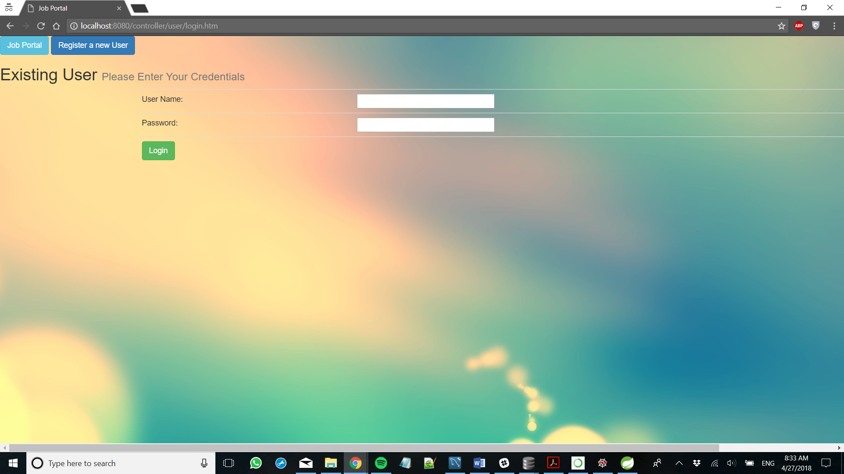



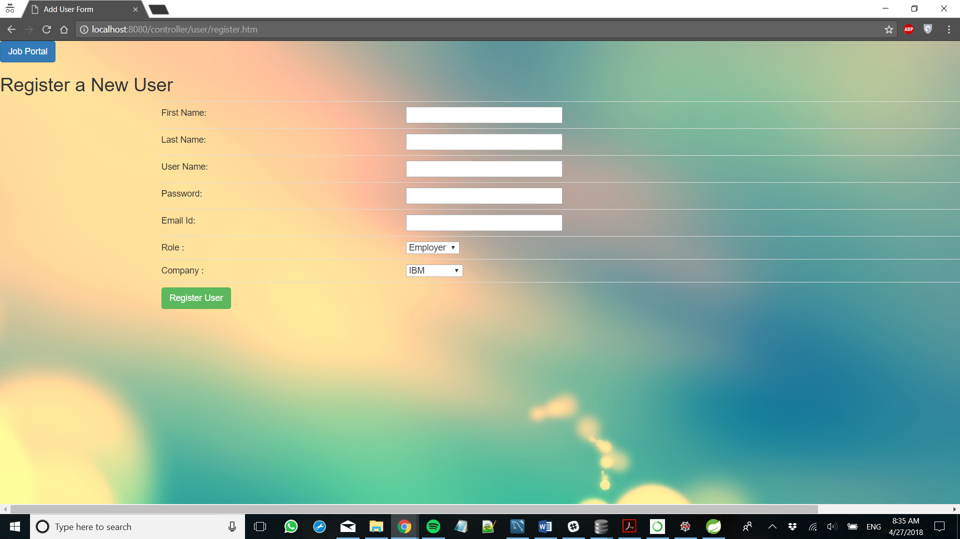





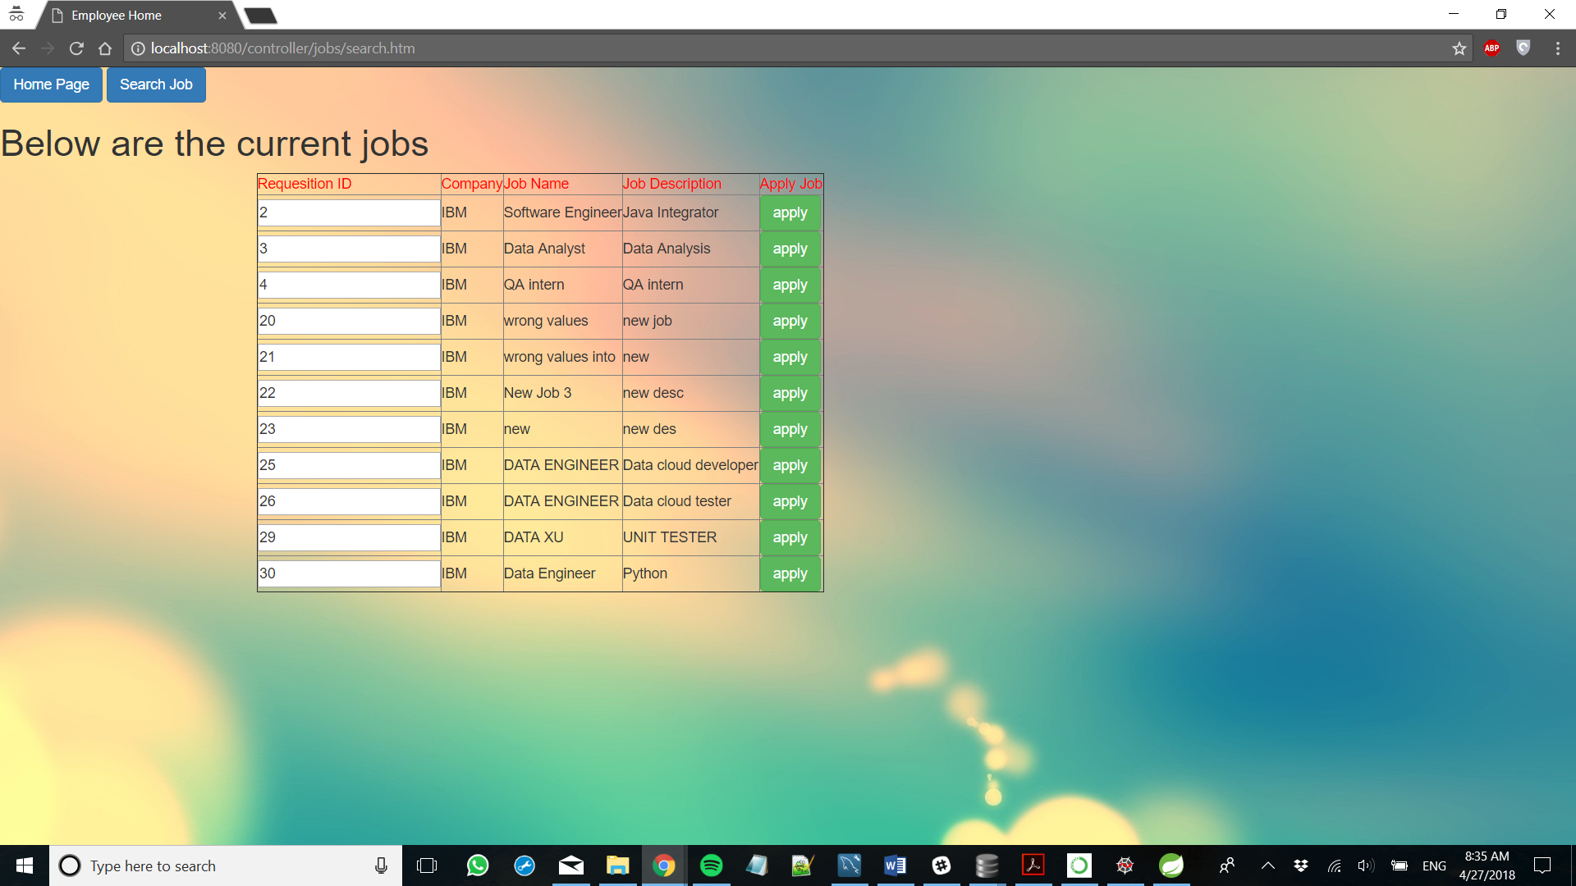



**package** com.me.JobPortal.controller;

**import** javax.servlet.http.HttpServletRequest;

**import** javax.servlet.http.HttpSession;

**import** org.springframework.stereotype.Controller;

**import** org.springframework.web.bind.annotation.RequestMapping;

**import** org.springframework.web.bind.annotation.RequestMethod;

**import** org.springframework.web.servlet.ModelAndView;

**import** com.me.JobPortal.pojo.JobList;

**import** com.me.JobPortal.pojo.User;

@Controller

@RequestMapping("/authorize/*")

**public** **class** AuthorizationController {

@RequestMapping(value = "/authorize/error.htm", method = RequestMethod.***GET***)

**protected** ModelAndView addjobs(HttpServletRequest request) **throws** Exception {

ModelAndView mv = **new** ModelAndView();

mv.setViewName("errorpage");

**return** mv;

}

@RequestMapping(value = "/authorize/JobUpdateError.htm", method = RequestMethod.***GET***)

**protected** ModelAndView errorjobs(HttpServletRequest request) **throws** Exception {

ModelAndView mv = **new** ModelAndView();

mv.setViewName("error-jobupdate");

**return** mv;

}

}

**package** com.me.JobPortal.controller;

**import** java.util.List;

**import** javax.servlet.http.HttpServletRequest;

**import** javax.servlet.http.HttpSession;

**import** org.springframework.beans.factory.annotation.Autowired;

**import** org.springframework.beans.factory.annotation.Qualifier;

**import** org.springframework.stereotype.Controller;

**import** org.springframework.validation.BindingResult;

**import** org.springframework.web.bind.WebDataBinder;

**import** org.springframework.web.bind.annotation.InitBinder;

**import** org.springframework.web.bind.annotation.ModelAttribute;

**import** org.springframework.web.bind.annotation.RequestMapping;

**import** org.springframework.web.bind.annotation.RequestMethod;

**import** org.springframework.web.servlet.ModelAndView;

**import** com.me.JobPortal.DAO.CompanyDAO;

**import** com.me.JobPortal.DAO.JobsDAO;

**import** com.me.JobPortal.DAO.UserDAO;

**import** com.me.JobPortal.exception.CompanyException;

**import** com.me.JobPortal.pojo.Company;

**import** com.me.JobPortal.pojo.JobList;

**import** com.me.JobPortal.pojo.User;

**import** com.me.JobPortal.validator.CompanyValidator;

@Controller

@RequestMapping("/company/*")

**public** **class** CompanyController {

@Autowired

@Qualifier("companyDao")

CompanyDAO companyDao;

@Autowired

@Qualifier("companyValidator")

CompanyValidator validator;

@Autowired

@Qualifier("jobsDao")

JobsDAO jobsDao;

@Autowired

@Qualifier("userDao")

UserDAO userDao;

@InitBinder

**private** **void** initBinder(WebDataBinder binder) {

binder.setValidator(validator);

}

@RequestMapping(value = "/company/register.htm", method = RequestMethod.***POST***)

**protected** ModelAndView registerNewUser(HttpServletRequest request, @ModelAttribute("company") Company company, BindingResult result) **throws** Exception {

validator.validate(company, result);

**if** (result.hasErrors()) {

**return** **new** ModelAndView("register-company", "company", company);

}

**try** {

System.***out***.print("registerNewCompany");

Company c = companyDao.register(company);

**return** **new** ModelAndView("company-add", "company", c);

} **catch** (CompanyException e) {

System.***out***.println("Exception: " + e.getMessage());

**return** **new** ModelAndView("error", "errorMessage", "error while registering company");

}

}

@RequestMapping(value = "/company/register.htm", method = RequestMethod.***GET***)

**protected** ModelAndView registerUser() **throws** Exception {

System.***out***.print("registerUser");

**return** **new** ModelAndView("register-company", "company", **new** Company());

}

@RequestMapping(value = "/company/delete.htm", method = RequestMethod.***POST***)

**protected** ModelAndView searchjobs(HttpServletRequest request) **throws** Exception {

ModelAndView mv = **new** ModelAndView();

HttpSession session = (HttpSession) request.getSession();

User u = (User) session.getAttribute("user");

**int** compId = Integer.*parseInt*(request.getParameter("compID"));

Company comp = companyDao.getById(compId);

// List<JobList> jobs = jobsDao.listCompany(comp);

companyDao.delete(comp);

mv.addObject("companies", companyDao.list());

mv.setViewName("admin-home");

**return** mv;

}

}

package com.me.JobPortal.controller;

import java.util.Date;

import java.util.List;

import javax.servlet.http.HttpServletRequest;

import javax.servlet.http.HttpSession;

import org.hibernate.HibernateException;

import org.springframework.beans.factory.annotation.Autowired;

import org.springframework.beans.factory.annotation.Qualifier;

import org.springframework.http.HttpRequest;

import org.springframework.mail.SimpleMailMessage;

import org.springframework.mail.javamail.JavaMailSender;

import org.springframework.stereotype.Controller;

import org.springframework.validation.BindingResult;

import org.springframework.web.bind.WebDataBinder;

import org.springframework.web.bind.annotation.InitBinder;

import org.springframework.web.bind.annotation.ModelAttribute;

import org.springframework.web.bind.annotation.RequestMapping;

import org.springframework.web.bind.annotation.RequestMethod;

import org.springframework.web.servlet.ModelAndView;

import com.me.JobPortal.DAO.CompanyDAO;

import com.me.JobPortal.DAO.JobsDAO;

import com.me.JobPortal.DAO.UserDAO;

import com.me.JobPortal.exception.JobsException;

import com.me.JobPortal.pojo.Company;

import com.me.JobPortal.pojo.JobList;

import com.me.JobPortal.pojo.User;

import com.me.JobPortal.validator.JobsValidator;

@Controller

@RequestMapping("/jobs/*")

public class JobsController {

@Autowired

@Qualifier("jobsDao")

JobsDAO jobsDao;

@Autowired

@Qualifier("userDao")

UserDAO userDao;

@Autowired

@Qualifier("companyDao")

CompanyDAO companyDao;

@Autowired

@Qualifier("jobsValidator")

JobsValidator validator;

@Autowired

private JavaMailSender mailSender;

@InitBinder

private void initBinder(WebDataBinder binder) {

binder.setValidator(validator);

}

@RequestMapping(value = "/jobs/register.htm", method = RequestMethod.GET)

protected ModelAndView addjobs(HttpServletRequest request) throws Exception {

ModelAndView mv = new ModelAndView();

HttpSession session = (HttpSession) request.getSession();

User u = (User) session.getAttribute("user");

mv.addObject("companyName", u.getCompany().getCompanyName());

mv.addObject("joblist", new JobList());

mv.setViewName("job-add");

return mv;

}

@RequestMapping(value = "/jobs/register.htm", method = RequestMethod.POST)

protected ModelAndView registerNewUser(HttpServletRequest request, @ModelAttribute("joblist") JobList joblist,

BindingResult result) throws Exception {

validator.validate(joblist, result);

if (result.hasErrors()) {

return new ModelAndView("job-add", "joblist", joblist);

}

try {

ModelAndView mv = new ModelAndView();

HttpSession session = (HttpSession) request.getSession();

User u = (User) session.getAttribute("user");

System.out.print("Add New Job");

joblist.setCompany(u.getCompany());

joblist.setPostedName(u.getFirstName());

joblist.setPostedID(u.getUsername());

JobList job = jobsDao.register(joblist);

mv.addObject("jobs", jobsDao.listCompany(u.getCompany()));

mv.addObject("joblist", job);

mv.setViewName("employer-home");

return mv;

} catch (JobsException e) {

System.out.println("Exception: " + e.getMessage());

return new ModelAndView("error", "errorMessage", "error while adding job");

}

}

@RequestMapping(value = "/jobs/update.htm", method = RequestMethod.GET)

protected ModelAndView updatejobs(HttpServletRequest request) throws Exception {

ModelAndView mv = new ModelAndView();

HttpSession session = (HttpSession) request.getSession();

int id = Integer.parseInt(request.getParameter("jobId"));

JobList job = jobsDao.getJob(id);

System.out.println("THE PRODUCT ID IS :" + id);

User u = (User) session.getAttribute("user");

mv.addObject("companyName", u.getCompany().getCompanyName());

// mv.addObject("joblist", new JobList());

mv.addObject("jobList", job);

mv.setViewName("job-update");

return mv;

}

@RequestMapping(value = "/jobs/update.htm", method = RequestMethod.POST)

protected ModelAndView updatejob(HttpServletRequest request) throws Exception {

ModelAndView mv = new ModelAndView();

HttpSession session = (HttpSession) request.getSession();

int id = Integer.parseInt(request.getParameter("jobId"));

JobList job = jobsDao.getJob(id);

job.setJobName(request.getParameter("jobName"));

job.setJobDesc(request.getParameter("jobDesc"));

System.out.println("THE PRODUCT ID IS :" + id);

jobsDao.update(job);

User u = (User) session.getAttribute("user");

// mv.addObject("companyName", u.getCompany().getCompanyName());

// mv.addObject("joblist", new JobList());

mv.addObject("jobList", job);

mv.setViewName("update-success");

return mv;

}

@RequestMapping(value = "/jobs/modify.htm", method = RequestMethod.POST)

protected ModelAndView modifyJob(HttpServletRequest request, @ModelAttribute("joblist") JobList joblist,

BindingResult result) throws Exception {

// validator.validate(joblist, result);

// if (result.hasErrors()) {

// return new ModelAndView("job-add", "joblist", joblist);

// }

try {

ModelAndView mv = new ModelAndView();

String action = request.getParameter("action");

int job_id = Integer.parseInt(request.getParameter("productID"));

System.out.println("the action is : " + action);

if (action.equals("Delete")) {

JobList job = jobsDao.getJob(job_id);

jobsDao.deleteJob(job);

mv.setViewName("employer-home");

}

return mv;

// HttpSession session = (HttpSession) request.getSession();

// User u = (User) session.getAttribute("user");

// System.out.print("Add New Job");

// joblist.setCompany(u.getCompany());

//

// JobList job = jobsDao.register(joblist);

// mv.addObject("jobs", jobsDao.listCompany(u.getCompany()));

// mv.addObject("joblist", job);

// mv.setViewName("employer-home");

// return mv;

} catch (JobsException e) {

System.out.println("Exception: " + e.getMessage());

return new ModelAndView("error", "errorMessage", "error while adding job");

}

}

@RequestMapping(value = "/jobs/add.htm", method = RequestMethod.POST)

protected ModelAndView addJob(HttpServletRequest request) throws Exception {

try {

boolean flag = false;

ModelAndView mv = new ModelAndView();

HttpSession session = (HttpSession) request.getSession();

User u = (User) session.getAttribute("user");

int job_id = Integer.parseInt(request.getParameter("jobID"));

for (JobList job1 : u.getJoblists()) {

if (job1.getJobID() == job_id) {

flag = true;

}

}

System.out.print("Add New Job");

if (!flag) {

JobList job = jobsDao.getJob(job_id);

// u.getJoblists().add(job);

userDao.update(u, job);

System.out.println("Entered the job addition new para");

job.getUsers().add(u);

jobsDao.update(job);

String address = u.getEmail().getEmailAddress();

String subject = "Job Applied Notification for " +job.getJobName();

String message = "Dear "+u.getFirstName()+","+"\n"+"\nYou Applied for the position : "+job.getJobName()+"\n"+"\nJob Desc : " +job.getJobDesc()

+"\non : " +new Date() +"\n"+"\n"+"\nThank you for using our online Job Portal"+"\n"+"\nRegards"+"\nAdmin";

SimpleMailMessage email = new SimpleMailMessage();

email.setTo(address);

email.setSubject(subject);

email.setText(message);

mailSender.send(email);

mv.addObject("jobs", jobsDao.listCompany(u.getCompany()));

mv.addObject("joblist", job);

mv.setViewName("add-success");

flag = false;

return mv;

} else {

System.out.println("Entered the other para where its already added");

mv.addObject("jobs", null);

mv.setViewName("add-already");

return mv;

}

} catch (JobsException e) {

System.out.println("Exception: " + e.getMessage());

return new ModelAndView("error", "errorMessage", "error while adding job");

}

}

@RequestMapping(value = "/jobs/search.htm", method = RequestMethod.GET)

protected ModelAndView searchjob(HttpServletRequest request) throws Exception {

ModelAndView mv = new ModelAndView();

HttpSession session = (HttpSession) request.getSession();

User u = (User) session.getAttribute("user");

// mv.addObject("companyName", u.getCompany().getCompanyName());

// mv.addObject("joblist", new JobList());

mv.setViewName("search-job");

return mv;

}

@RequestMapping(value = "/jobs/search.htm", method = RequestMethod.POST)

protected ModelAndView searchjobs(HttpServletRequest request) throws Exception {

ModelAndView mv = new ModelAndView();

HttpSession session = (HttpSession) request.getSession();

User u = (User) session.getAttribute("user");

String name = request.getParameter("inputtext");

String search = request.getParameter("searchkey");

if (search.equalsIgnoreCase("jobname")) {

List<JobList> jobs = jobsDao.listJobname(name);

mv.addObject("jobs", jobs);

if (jobs.isEmpty())

System.out.println("The returned list is empty");

for (JobList job : jobs) {

System.out.println("The matching jobs are : " + job.getJobName());

}

} else if (search.equalsIgnoreCase("company")) {

Company c = companyDao.get(name);

if (c == null) {

mv.setViewName("search-fail");

return mv;

}

List<JobList> jobs = jobsDao.listCompany(c);

if (jobs.isEmpty()) {

mv.setViewName("search-failjobs");

return mv;

}

mv.addObject("jobs", jobs);

}

mv.setViewName("search-success");

return mv;

}

@RequestMapping(value = "/jobs/applied.htm", method = RequestMethod.GET)

protected ModelAndView appliedjob(HttpServletRequest request) throws Exception {

ModelAndView mv = new ModelAndView();

// HttpSession session = (HttpSession) request.getSession();

// User u = (User) session.getAttribute("user");

// mv.addObject("companyName", u.getCompany().getCompanyName());

// mv.addObject("joblist", new JobList());

mv.setViewName("jobs-applied");

return mv;

}

@RequestMapping(value = "/jobs/viewalljobs.htm", method = RequestMethod.GET)

protected ModelAndView viewAllJob(HttpServletRequest request) throws Exception {

ModelAndView mv = new ModelAndView();

// HttpSession session = (HttpSession) request.getSession();

// User u = (User) session.getAttribute("user");

// mv.addObject("companyName", u.getCompany().getCompanyName());

// mv.addObject("joblist", new JobList());

mv.addObject("jobs", jobsDao.list());

mv.setViewName("viewalljobs");

return mv;

}

}

package com.me.JobPortal.controller;

import java.util.Set;

import javax.servlet.http.HttpServletRequest;

import javax.servlet.http.HttpSession;

import org.springframework.beans.factory.annotation.Autowired;

import org.springframework.beans.factory.annotation.Qualifier;

import org.springframework.stereotype.Controller;

import org.springframework.validation.BindingResult;

import org.springframework.web.bind.WebDataBinder;

import org.springframework.web.bind.annotation.InitBinder;

import org.springframework.web.bind.annotation.ModelAttribute;

import org.springframework.web.bind.annotation.RequestMapping;

import org.springframework.web.bind.annotation.RequestMethod;

import org.springframework.web.servlet.ModelAndView;

import com.me.JobPortal.DAO.CompanyDAO;

import com.me.JobPortal.DAO.JobsDAO;

import com.me.JobPortal.DAO.UserDAO;

import com.me.JobPortal.exception.UserException;

import com.me.JobPortal.pojo.Company;

import com.me.JobPortal.pojo.JobList;

import com.me.JobPortal.pojo.User;

import com.me.JobPortal.validator.UserValidator;

@Controller

@RequestMapping("/user/*")

public class UserController {

@Autowired

@Qualifier("userDao")

UserDAO userDao;

@Autowired

@Qualifier("userValidator")

UserValidator validator;

@Autowired

@Qualifier("companyDao")

CompanyDAO companyDao;

@Autowired

@Qualifier("jobsDao")

JobsDAO jobsDao;

@InitBinder

private void initBinder(WebDataBinder binder) {

binder.setValidator(validator);

}

@RequestMapping(value = "/user/login.htm", method = RequestMethod.GET)

protected String goToUserHome(HttpServletRequest request) throws Exception {

return "home";

}

@RequestMapping(value = "/user/login.htm", method = RequestMethod.POST)

protected ModelAndView loginUser(HttpServletRequest request) throws Exception {

ModelAndView mv = new ModelAndView();

HttpSession session = (HttpSession) request.getSession();

try {

System.out.print("loginUser");

User u = userDao.get(request.getParameter("username"), request.getParameter("password"));

if(u == null){

System.out.println("UserName/Password does not exist");

session.setAttribute("errorMessage", "UserName/Password does not exist");

mv.setViewName("error");

return mv;

}

session.setAttribute("user", u);

String role = u.getRole().trim();

if (role.equals("employee")){

System.out.println("Entered here");

// Set<JobList> job = u.getJoblists();

// System.out.println("The email addrees of Employee : " +u.getFirstName()+" is "+u.getEmail().getEmailAddress());

mv.addObject("jobs", jobsDao.list());

mv.setViewName("employee-home");

return mv ;

}

else if (role.equals("employer")){

// System.out.println("Entered in the region");

// System.out.println("The company id of the user is : " +u.getCompany().getCompanyId());

// mv.addObject("company", u.getCompany().getCompanyName());

// System.out.println("The email addrees of Employer : " +u.getFirstName()+" is "+u.getEmail().getEmailAddress());

mv.addObject("jobs", jobsDao.listCompany(u.getCompany()));

mv.setViewName("employer-home");

return mv;

}

else if(role.equals("admin")){

// System.out.println("The email addrees of Admin : " +u.getFirstName()+" is "+u.getEmail().getEmailAddress());

mv.addObject("companies", companyDao.list());

mv.setViewName("admin-home");

return mv;

}

else

return null;

} catch (UserException e) {

System.out.println("Exception: " + e.getMessage());

session.setAttribute("errorMessage", "error while login");

mv.setViewName("error");

return mv;

}

}

@RequestMapping(value = "/user/register.htm", method = RequestMethod.GET)

protected ModelAndView registerUser() throws Exception {

System.out.print("registerUser");

ModelAndView mv = new ModelAndView();

mv.addObject("companies", companyDao.list());

mv.addObject("user",new User());

mv.setViewName("register-user");

// return new ModelAndView("register-user", "user", new User());

return mv;

}

@RequestMapping(value = "/user/employee.htm", method = RequestMethod.GET)

protected ModelAndView employeeHome() throws Exception {

System.out.print("Employee Home");

ModelAndView mv = new ModelAndView();

mv.addObject("jobs", jobsDao.list());

mv.setViewName("employee-home");

// return new ModelAndView("register-user", "user", new User());

return mv;

}

@RequestMapping(value = "/user/employer.htm", method = RequestMethod.GET)

protected ModelAndView employerHome(HttpServletRequest request) throws Exception {

System.out.print("Employeer Home");

HttpSession session = (HttpSession) request.getSession();

User u = (User) session.getAttribute("user");

ModelAndView mv = new ModelAndView();

mv.addObject("jobs", jobsDao.listCompany(u.getCompany()));

mv.setViewName("employer-home");

return mv;

// return new ModelAndView("register-user", "user", new User());

}

@RequestMapping(value = "/user/admin.htm", method = RequestMethod.GET)

protected ModelAndView adminHome() throws Exception {

System.out.print("Admin Home");

ModelAndView mv = new ModelAndView();

mv.addObject("companies", companyDao.list());

mv.setViewName("admin-home");

// return new ModelAndView("register-user", "user", new User());

return mv;

}

@RequestMapping(value = "/user/register.htm", method = RequestMethod.POST)

protected ModelAndView registerNewUser(HttpServletRequest request, @ModelAttribute("user") User user, BindingResult result) throws Exception {

validator.validate(user, result);

if (result.hasErrors()) {

// return new ModelAndView("register-user", "user", user);

ModelAndView mv = new ModelAndView();

mv.addObject("companies", companyDao.list());

mv.addObject("user", user);

mv.setViewName("register-user");

return mv;

}

try {

System.out.print("registerNewUser");

String role = request.getParameter("myRole");

user.setRole(role);

String company = request.getParameter("myCompany");

System.out.println("The Company is :" +company);

Company c = companyDao.get(company);

System.out.println("The company ID : " +c.getCompanyId());

user.setCompany(c);

User u = userDao.register(user);

request.getSession().setAttribute("user", u);

return new ModelAndView("user-home", "user", u);

} catch (UserException e) {

System.out.println("Exception: " + e.getMessage());

return new ModelAndView("error", "errorMessage", "error while login");

}

}

}

package com.me.JobPortal.pojo;

import javax.persistence.Column;

import javax.persistence.Entity;

import javax.persistence.GeneratedValue;

import javax.persistence.GenerationType;

import javax.persistence.Id;

import javax.persistence.Table;

@Entity

@Table(name = "companytable")

public class Company {

@Id

@GeneratedValue(strategy=GenerationType.AUTO)

@Column(name="companyid")

private int companyId;

@Column(name="companyname")

private String companyName;

@Column(name="companyaddress")

private String companyAddress;

@Column(name="companydesc")

private String companyDescription;

public Company(){

}

public Company( String companyName, String companyAddress, String companyDescription){

this.companyName = companyName;

this.companyAddress = companyAddress;

this.companyDescription = companyDescription;

}

public int getCompanyId() {

return companyId;

}

public void setCompanyId(int companyId) {

this.companyId = companyId;

}

public String getCompanyName() {

return companyName;

}

public void setCompanyName(String companyName) {

this.companyName = companyName;

}

public String getCompanyAddress() {

return companyAddress;

}

public void setCompanyAddress(String companyAddress) {

this.companyAddress = companyAddress;

}

public String getCompanyDescription() {

return companyDescription;

}

public void setCompanyDescription(String companyDescription) {

this.companyDescription = companyDescription;

}

}

package com.me.JobPortal.pojo;

import javax.persistence.Column;

import javax.persistence.Entity;

import javax.persistence.GeneratedValue;

import javax.persistence.GenerationType;

import javax.persistence.Id;

import javax.persistence.OneToOne;

import javax.persistence.PrimaryKeyJoinColumn;

import javax.persistence.Table;

import org.hibernate.annotations.Parameter;

import org.hibernate.annotations.GenericGenerator;

@Entity

@Table(name = "email_table")

public class Email {

@Id

@GeneratedValue(strategy = GenerationType.AUTO)

// @GenericGenerator(name = "generator", strategy = "foreign", parameters = @Parameter(name = "property", value = "user"))

@Column(name = "emailID", unique = true)

private long id;

@Column(name = "email_address")

private String emailAddress;

@OneToOne

@PrimaryKeyJoinColumn

private User user;

public Email() {

}

public Email(String emailAddress) {

this.emailAddress = emailAddress;

}

public long getId() {

return id;

}

public void setId(long id) {

this.id = id;

}

public String getEmailAddress() {

return emailAddress;

}

public void setEmailAddress(String emailAddress) {

this.emailAddress = emailAddress;

}

public User getUser() {

return user;

}

public void setUser(User user) {

this.user = user;

}

}

package com.me.JobPortal.pojo;

import javax.persistence.CascadeType;

import javax.persistence.Column;

import javax.persistence.Entity;

import javax.persistence.GeneratedValue;

import javax.persistence.GenerationType;

import javax.persistence.Id;

import javax.persistence.ManyToOne;

import javax.persistence.OneToOne;

import javax.persistence.PrimaryKeyJoinColumn;

import javax.persistence.Table;

@Entity

@Table(name = "Employer_Table")

@PrimaryKeyJoinColumn(name = "employeeID")

public class Employer extends User {

// @Id

// @GeneratedValue(strategy=GenerationType.AUTO)

// @Column(name = "employerID", unique=true, nullable = false)

// private int empID;

// @ManyToOne(cascade = CascadeType.ALL)

//// @Column(name = "company_id")

private Company company;

public Employer(){

}

public Company getCompany() {

return company;

}

public void setCompany(Company company) {

this.company = company;

}

}

package com.me.JobPortal.pojo;

import java.util.Set;

import java.util.Date;

import javax.persistence.CascadeType;

import javax.persistence.Column;

import javax.persistence.Entity;

import javax.persistence.GeneratedValue;

import javax.persistence.GenerationType;

import javax.persistence.Id;

import javax.persistence.ManyToMany;

import javax.persistence.ManyToOne;

import javax.persistence.PrimaryKeyJoinColumn;

import javax.persistence.Table;

import javax.persistence.Transient;

@Entity

@Table(name = "Jobs")

public class JobList {

@Id

@GeneratedValue(strategy=GenerationType.AUTO)

@Column(name = "jobID", unique=true, nullable = false)

private int jobID;

@Column(name = "jobname")

private String jobName;

@Column(name = "jobDesc")

private String jobDesc;

@Column(name = "uname")

private String postedName;

@Column(name = "uId")

private String postedID;

@Column(name = "posteddate")

private Date postedDate;

@ManyToOne

@PrimaryKeyJoinColumn

private Company company;

@ManyToMany(mappedBy="joblists")

private Set<User> users;

public JobList(){

}

public JobList(String jobname, String jobdesc){

this.jobName = jobname;

this.jobDesc = jobdesc;

this.postedDate = new Date();

}

public int getJobID() {

return jobID;

}

public void setJobID(int jobID) {

this.jobID = jobID;

}

public Set<User> getUsers() {

return users;

}

public void setUsers(Set<User> users) {

this.users = users;

}

public String getJobName() {

return jobName;

}

public void setJobName(String jobName) {

this.jobName = jobName;

}

public String getJobDesc() {

return jobDesc;

}

public void setJobDesc(String jobDesc) {

this.jobDesc = jobDesc;

}

public Company getCompany() {

return company;

}

public void setCompany(Company company) {

this.company = company;

}

public String getPostedName() {

return postedName;

}

public void setPostedName(String postedName) {

this.postedName = postedName;

}

public String getPostedID() {

return postedID;

}

public void setPostedID(String postedID) {

this.postedID = postedID;

}

public Date getPostedDate() {

return postedDate;

}

public void setPostedDate(Date postedDate) {

this.postedDate = postedDate;

}

}

package com.me.JobPortal.pojo;

import javax.persistence.Column;

import javax.persistence.Entity;

import javax.persistence.GeneratedValue;

import javax.persistence.GenerationType;

import javax.persistence.Id;

import javax.persistence.Inheritance;

import javax.persistence.InheritanceType;

import javax.persistence.Table;

@Entity

@Table(name="person_table")

@Inheritance(strategy=InheritanceType.JOINED) //table per subclass

public class Person {

@Id

@GeneratedValue(strategy=GenerationType.IDENTITY)

@Column(name = "personID", unique=true, nullable = false)

private long personID;

@Column(name = "firstName")

private String firstName;

@Column(name ="lastName")

private String lastName;

public Person(){

}

public long getPersonID() {

return personID;

}

public void setPersonID(long personID) {

this.personID = personID;

}

public String getFirstName() {

return firstName;

}

public void setFirstName(String firstName) {

this.firstName = firstName;

}

public String getLastName() {

return lastName;

}

public void setLastName(String lastName) {

this.lastName = lastName;

}

}

package com.me.JobPortal.pojo;

import java.util.HashSet;

import java.util.Set;

import javax.persistence.CascadeType;

import javax.persistence.Column;

import javax.persistence.Entity;

import javax.persistence.FetchType;

import javax.persistence.Inheritance;

import javax.persistence.InheritanceType;

import javax.persistence.JoinTable;

import javax.persistence.ManyToMany;

import javax.persistence.ManyToOne;

import javax.persistence.OneToMany;

import javax.persistence.OneToOne;

import javax.persistence.PrimaryKeyJoinColumn;

import javax.persistence.Table;

import javax.persistence.JoinColumn;

import org.springframework.beans.factory.annotation.Autowired;

@Entity

@Table(name = "user_table")

@PrimaryKeyJoinColumn(name = "personID")

//@Inheritance(strategy=InheritanceType.JOINED)

public class User extends Person {

@Column(name = "userName")

private String username;

@Column(name = "password")

private String password;

@OneToOne(cascade = CascadeType.ALL)

private Email email;

@Column(name = "role")

private String role;

@ManyToOne

private Company company;

@ManyToMany

@JoinTable (

name="user_job_table",

joinColumns = {@JoinColumn(name="personID", nullable = false, updatable = false)},

inverseJoinColumns = {@JoinColumn(name="jobID" )}

)

private Set<JobList> joblists = new HashSet<JobList>();

public User(String username, String password, String role) {

this.username = username;

this.password = password;

this.role = role;

}

public User() {

}

public String getUsername() {

return username;

}

public void setUsername(String username) {

this.username = username;

}

public String getPassword() {

return password;

}

public void setPassword(String password) {

this.password = password;

}

public Email getEmail() {

return email;

}

public void setEmail(Email email) {

this.email = email;

}

public String getRole() {

return role;

}

public void setRole(String role) {

this.role = role;

}

public Company getCompany() {

return company;

}

public void setCompany(Company company) {

this.company = company;

}

public Set<JobList> getJoblists() {

return joblists;

}

public void setJoblists(Set<JobList> joblists) {

this.joblists = joblists;

}

}